**INTRODUCTION TO DEBATING AT LINCOLN’S INN**

Welcome to the Lincoln’s Inn Debating Society. If you have never debated before, don’t worry! This introduction will give you a quick overview of how to debate, what to expect at our workshops, and the opportunities we offer throughout the year. If you have any questions, you can email the debating secretaries Brittny and Michael at [lincolnsinndebatingclub@gmail.com](mailto:lincolnsinndebatingclub@gmail.com), or speak to any of the judges at a workshop.

**Why do we debate at Lincoln’s Inn?**

Lincoln’s uses debating as a tool to train advocacy. This means we approach it slightly differently than in university debating societies. Using debating, we will ensure you can command an audience and marshal an argument, respond to the unexpected quickly and effectively, and have the confidence to tackle areas of law and fact you have not considered before. The lack of preparation time means that we can focus directly on your advocacy skills, rather than the content of your legal arguments or how much research you’ve done. We are less concerned about who ‘wins’ a particular debate, and more interested in helping you improve your skills of persuasion.

**What happens at Debating workshops?**

Unlike mooting, there is no need to prepare for a debating workshop (or even the possibility of doing so). When you arrive, you will be assigned a speaking position and given the motion that you will be debating. Find your partner, as detailed below, and plan out your speeches. You will usually have about 15-20 minutes to prepare; if you have questions, the secretaries and judges will be circulating and can help.

The debate itself will generally last about 45 minutes. Following the debate the head judge will give general feedback to the room; individual feedback will be given during the drinks reception after.

**Debating Basics**

We run a simplified version of what is known as ‘British Parliamentary’ debating. It shares certain features with what you may have seen on the news, though usually less rude.

There are 8 speakers in each debate, divided between the proposition (ie the government) and the opposition, often referred to as ‘prop’ and ‘opp’. Simply put, the government proposes a motion and the opposition opposes it (see more on individual speakers’ roles below).

Motions frequently propose a change in policy, but sometimes are a general statement of support. They usually start with either ‘This House Would’ (THW), ‘This House Believes That’ (THBT), or occasionally ‘This House Regrets’ (THR). By way of example, we have previously run:

* THW bring back corporal punishment
* THW abolish juries
* THW never decide anything by referendum ever again
* THBT Donald Trump is good for politics
* THR dating apps

You will give your speech standing at the end of the table, facing the judges.

***Roles***

The proposition and opposition sides are divided into two teams, with the first and second speakers being one team (‘opening government/opening opposition’) and the third and fourth speakers being a team (‘closing government/closing opposition’).

The speakers alternate across the table. For those adhering to tradition, the order of speakers is as follows:

1. Prime Minister (1st Proposition)
2. Leader of the Opposition (1st Opposition)
3. Deputy Prime Minister (2nd Proposition)
4. Deputy Leader of the Opposition (2nd Opposition)
5. Member of Government (3rd Proposition)
6. Member of Opposition (3rd Opposition)
7. Government Whip (4th Proposition)
8. Opposition Whip (4th Opposition)

The seating arrangement will look like this:

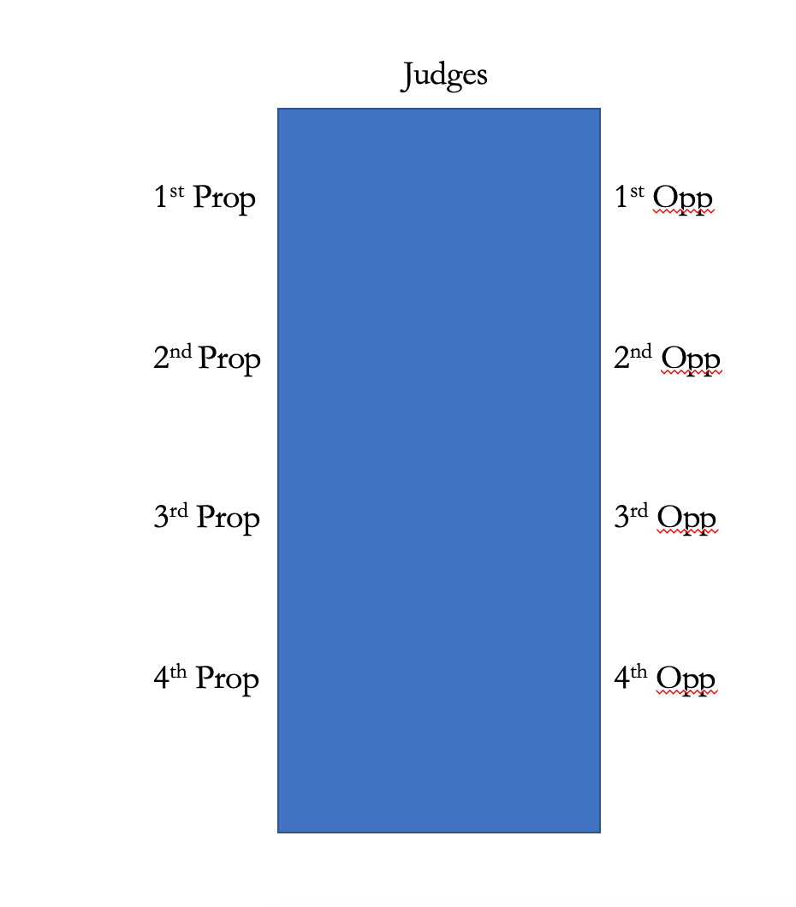

Teamwork is an important part of debating: the most successful teams plan out their speeches together and refer to the points their teammate has made or will make within their speech. Particularly if you are coming up short on ideas, talking through the motion and bouncing ideas off your partner can be a lifesaver.

Different speakers have different roles to fulfil in the debate, and the best debates are those where these roles are carried out. We do not penalise speakers for not fulfilling their role, but be aware if you attend debating competitions that judges will do so. By way of overview:

**1st Prop:** The 1st proposition speaker has an important task: define the motion. What is the government proposing to do? What will their policy be? (Brexit means Brexit is not a good model!) It is usually easiest to start by explaining what the problem is, set out what your suggested solution is, and explain how this will make things better. This will take some time, so it is often a good idea to allow 2nd Prop to expand on the details.

Bold cases make for better debates than uncontroversial ones. Debates are won on arguments, not reality – making a persuasive case for something outlandish can win you lots of points. Be wary of ‘squirrelling the motion’, ie trying to interpret it in a way that was clearly not intended. If the judges set a motion such as ‘THW allow the sale of babies on the open market’, they will not be happy if your model is encouraging private provision of IVF. They expect to see a proposal to swap babies for money.

**1st Opp:** The 1st Opposition speaker should aim to make a substantive case for why either the status quo or a different model would have a better result.

**2nd Prop/2nd Opp:** The 2nd speakers on both sides will then expand on the opening speaker’s position.

**3rd Prop/3rd Opp (extension speakers)**: The 3rd speakers on each side have a somewhat tricky task. They need to support the case made by the top half of the table, but also extend it with their own ideas or a different approach.

**4th Prop/4th Opp (summary speakers):** Finally, the final speakers on each side have the task of summarising the debate and explaining why their side won. They may not introduce any new arguments. A typical strategy is to recap themes that have emerged in the debate or the main points of clash.

***Timing and Points of Information***

You will speak for no more than 5 minutes – feel free to use the timer on your phone to help with timekeeping. The first and last minutes are ‘protected time’, during which you will speak uninterrupted. After the first minute the judge will indicate that protected time has ended. From then until the end of the fourth minute, members of the other team are free to offer you what are known as ‘points of information’ or POIs.

POIs are short questions asked to the Speaker. They are not an opportunity to make your own speech. You might point out a logical flaw in the speaker’s argument, or give an example that disproves their point. The speaker should respond briefly, but do not allow yourself to get dragged into an argument! It is your speech and you should retain control. Deal with the point and move swiftly on.

POIs are given by standing up, extending a hand, and saying ‘Point of information’ or ‘On that point’. The Speaker may choose to accept or decline a POI; if you are in the middle of a point, you can also ignore them or say ‘in a minute’. It is perfectly fine to decline a POI by waving the offeror down.

You should aim to take at least one POI during your speech. More than two may make it difficult to get through your material – if you are short of things to say, however, accepting lots of POIs may be a blessing. When you are not the speaker, use POIs to remain part of the debate and continue pushing your position.

***Content and structure***

It is always helpful to begin by signposting the points you’re going to make – this helps the judges keep track of where you’re going, and also ensures that you know you actually have something to say before you stand up. Remember the Rule of Three: (i) tell them what you’re going to tell them; (ii) tell them; and (iii) tell them what you’ve told them. It may seem trite, but it really does work.

Unless you are the 1st Prop speaker, you will also want to begin by rebutting a few of the points made by the speaker before you. This can come after you set out your substantive points. Do not spend too much time in rebuttal though: make your own case.

Examples are always helpful, and will lend weight to your arguments. However, you may *not* do any research online once you know the motion. If you present a barrage of statistics, the judges are likely to suspect you’ve forgotten this rule. For debating (as for pupillage interviews) you will be rewarded for keeping up with current events. Skimming a newspaper’s website daily is hardly onerous and should be considered the bare minimum.

Beware of ‘debate speed’. Some university debating societies teach speakers to speak very, very quickly (double normal speaking speed is not uncommon). Whilst this means they can talk about more ideas, speaking in this style would be completely unacceptable and ineffective in court, and so we do not use ‘debate speed’. Please deliver your speech at an ordinary, relaxed pace, as you would expect to do in court. This is a good opportunity to practise watching the judge’s pen: if your judge cannot keep up with you, it’s time to slow down.

Finally, debating is far more creative and relaxed than mooting. Be funny or outrageous, or clever, or passionate, but above all try not to be boring!

**Competitions and Debates in Hall**

At each workshop you will have the opportunity to put your name forward for additional debating events. First, the Inn sends teams to a number of debating competitions throughout the year. These are good fun and a great chance to get a lot of debating experience very quickly. They are generally hosted by university debating societies over the course of a weekend. If you are selected for a competition, you *must* attend the entire weekend – leaving halfway through does not reflect well on the Inn and lets your partner down.

We also hold a few debates in Hall every year, where two teams hold a debate following a dining session. These are often attended by benchers and allow you to show your skills to a wider audience of the Inn’s members.

Finally, there is the prestigious Debating Shield! A semi-final round is held at the final workshop of the year, and the final 8 teams compete at a public event judged by Bar and Bench members. There actually is a shield, on which the winning team’s names are engraved each year. (You may recognise some of the names on it.) All finalists are invited to dine in Hall on the Bar table, and the winning pair will each receive a bottle of the finest Lincoln’s Inn champagne.